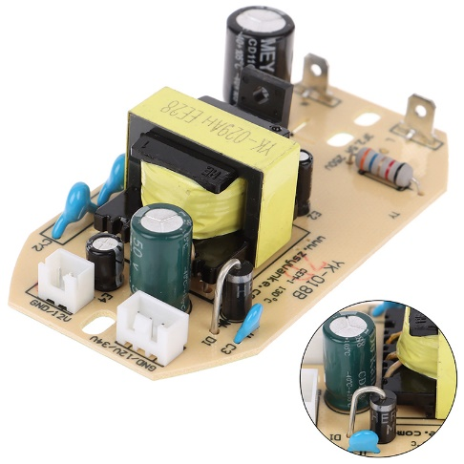

Humidifier Board Replacement Part Atomization Circuit Plate Module

Product details of 1Pc 12V/34V Humidifier Board Replacement Part Atomization Circuit Plate Module

* Features:
* 100% brand new and high quality
* This board is a component for humidifier,professional replacement for humidifier.
* Universal part and apply to majority of humidifier,excellent for electric appliance serviceman.
* 12V/34V output voltage and 35W power supply,adopts high quality and durable materials and original technique.
* Specification:
* Type: Humidifier Component
* Output Voltage: 12/34V
* Input Voltage: 220V
* Power: 35W
* Size: 93\*50mm
* Package includes:1 x Humidifier Board
* Note:
* Please allow 0-1cm error due to manual measurement. pls make sure you do not mind before you bid.
* Due to the difference between different monitors, the picture may not reflect the actual color of the item. Thank you!